Recently, metal nanoparticles attract much attention as catalytic systems for chemical reactions of gasses. We focus our attention on PdRu-based alloys since they are expected to be high-performance and low-cost catalysts to remove CO and NOx in exhaust gas of cars. Pd and Ru form bulk solid solutions only at much higher temperatures than room temperature. This is mainly because Pd has an fcc structure while Ru has an hcp one. We have found that PdxRu1-x with a diameter of 5- 7 nm are miscible in the whole composition range around room temperature [1]. However, there is still microscopic phase separation between the fcc and hcp phases in a single nanoparticle and transpiration of Ru atoms occurs at higher temperatures. It is the present largest problem why the endurance of catalytic ability strongly depends on the composition of the flow gases which are similar to actual exhaust gases of cars:

Structure and catalytic activity of PdRu alloy nanoparticles

O. Yamamuro*A*, H. Akiba*A*, K. Kusada*B*, M. Haneda*C*, H. Kitagawa*B*, D. Keen*D*

*AISSP-NSL, Univ. of Tokyo, BKyoto Univ., CNagoya Institute of Technology, DISIS, RAL*

Stoichi: NO:0.15%, O2:0.3%, C3H6:0.033%,

H2:0.1%, CO:0.35%

Rich: NO:0.15%, O2:0.15%, C3H6:0.033%,

H2:0.1%, CO:0.35%

Lean: NO:0.15%, O2:0.45%, C3H6:0.033%,

H2:0.1%, CO:0.35%

Rich and Lean mean that the ratio of CO gas is respectively larger and smaller than the stoichiometric one for the complete CO and C3H6 oxidization and NO reduction; we change the ratio of O2 gas, not CO gas, in the actual experiments as shown above. In this study, we have performed the neutron powder diffraction (NPD) experiments of PdRu nanoparticles supported on CZ (CeO2-ZrO2) to elucidate the structural change of nanoparticles caused by the catalytic reactions with the three gases given above. The NPD measurements were conducted using the high-intensity neutron powder diffractometer (GEM) installed at RAL, ISIS. NPD is powerful to distinguish between neighboring atoms in the periodic table such as Pd and Ru. A furnace with a special double-cylinder gas-flow cell and a mass flow controller were used in the experiment.

Figure 1 shows the NPD patterns of Pd0.5 Ru0.5 nanoparticles supported on CZ before and after the Rich and Lean gas treatments at 673 K. The black, blue and red bars represent the peak positions calculated for the fcc structure of CZ, and the fcc and hcp structures of PdRu nanoparticles, respectively. The Lean sample (blue curve) has larger fcc intensity than the Rich sample (red curve). This result indicates that Ru atoms inside the nanoparticles move to the surface and the Pd-rich fcc phase increases in the interior region. This is consistent with our previous IR study and will be more definite by an on-going pdf (pair-distribution function) analyses. It should be noted that this is the first in-situ NPD data showing the structural change of nanoparticles due to catalytic reactions.

[1] K. Kusada *et al*., J. Am. Chem. Soc. **136**, 1864 (2014).

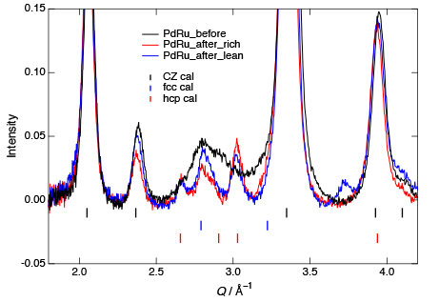

Fig. 1. Neutron diffraction patterns of Pd0.5Ru0.5 nanoparticles supported on CZ before (black) and after (red and blue) the catalytic reactions with Rich and Lean gases.